Revision Date: | 2015MAR | State of Illinois Emergency Management Agency | Hazard ID: | WINTER STORM
Revised By: |  |  | Use By:

SHORT-TERM RESPONSE OBJECTIVES |  | RESOURCE GUIDELINE FOR RESPONSE
- Conduct Search and Rescue  - Conduct Well Being Checks  - Implement Life Essential Supply Missions  - Provide Public Information Messaging  - Establish Evacuation Systems  - Establish Shelters/Warming Centers Establish Immediate EMS/Medical Surge Capacity  - Provide Force Security & Protection  - Restore Communications  - Restore Power  - Restore WWTF and Potable Water Supplies/Systems  - Conduct Snow Removal/Management  SECONDARY CONSIDERATIONS  - Environmental impact  - Loss of economy and infrastructure  - Loss of equipment due to hazard profile  - Mass Care  - Medical implications - capability/capacity  - Requests for potable water supplies  - Requests for waste management services  - Requests for portable heating  - Responder health and welfare  - Personnel Protective Equipment  - Fatality Management  - Food Service/Supply Inspections |  | RESOURCE TYPE | QNTY | PURPOSE
 |  | IEMA Regional Coordinator  Sworn Officer – L/E  ING (Personnel)  ING (HUMVEE)  Snowmobiles  Graders  Trucks w/ Plows  Generators (5 – 100kw, 5 -30Kw) IESMA  Generator Trailers - IESMA  Message Boards  Arrow Boards  Sweeper  HWY Labor (Personnel)  Day Labor, General (Personnel)  Cessna 237  H – Sikorsky S-76B  H – Bell 206L3  Radios, Portable, STARCOM |  | Liaison w/ County EOC’s  Force Security and Protection / T/A / SAR  Force Security and Protection / T/A / SAR  Force Security and Protection / T/A / SAR  Transportation / SAR / Life Essential Missions  Snow removal / T/A  Above IDOT Winter Storm Plan base  Power Restoration  Power Restoration  Public information and Messaging  Public information and Messaging  Snow removal  Snow Removal and Management  Snow Removal and Management/ Res Mgmt  Aerial Monitoring  Aerial Monitoring  Aerial Monitoring  Communications

 | SAFETY CONSIDERATIONS AND WARNINGS
- Staff will maintain a safe working environment throughout operations.
- Staff will wear designated and approved safety gear/clothing during missions and periods of active duty.
- Due to the extended working period, staff will be cognizant of stress, fatigue, and the need for adequate rest periods.
- All staff should be cognizant of potential trip, slip, fall, cold, and environmental conditions associated with operations.
- Any and all situations warranting law enforcement intervention will be immediately directed to the appropriate authorities.
- Injuries or medical concerns/conditions will be reported to the medical staff on-site immediately and/or 911 as appropriate.
GLOSSARY OF TERMS |  |  | REFERENCES | RULES OF THUMB
- Blizzard  A storm which contains large amounts of snow OR blowing snow, with winds in excess of 35 mph and visibilities of less than 1/4 mile for an extended period of time (at least 3 hours).  - Winter Storm Warning  Issued when hazardous winter weather in the form of heavy snow, heavy freezing rain, or heavy sleet is imminent or occurring. Winter Storm Warnings are usually issued 12 to 24 hours before the event is expected to begin.  - Winter Storm Watch  Alerts the public to the possibility of a blizzard, heavy snow, heavy freezing rain, or heavy sleet. Winter Storm Watches are usually issued 12 to 48 hours before the beginning of a Winter Storm.  - Wind Chill Warning:  Issued when wind chill temperatures are expected to be hazardous to life within several minutes of exposure.  - Ice Storm  An ice storm is used to describe occasions when damaging accumulations of ice are expected during freezing rain situations. Significant ice accumulations are usually accumulations of ¼" or greater.  - Ice Storm Warning  Issued when freezing rain produces a significant and possibly damaging accumulation of ice. The criteria for this warning varies from state to state, but typically will be issued any time more than 1/4" of ice is expected to accumulate in an area.  http://w1.weather.gov/glossary/ |  |  | - National Weather Service (NWS)  Approximate snowfall to rain equivalency ratios:  Average Dense Powdery  10 to 1 8 to 1 14 to 1  - IDOT – Roadways/Traffic  Emergency Road Closures  http://www.dot.il.gov/road/closures.txt  Roadway Weather Information System (RWIS)  http://www.gettingaroundillinois.com/gai.htm?mt=rwis | - If temperatures are below 18°F for a period of 72-hours or more, salt becomes ineffective  - If temperatures remain above 18° and icing is less than ½”, salt will remain effective.  - Every 72-hours of operation, 1/3 of the snow removal equipment that is in-service will be placed out-of-service for repair and replacement.
 |  |  | WIND CHILL CHART |  | LINKS
 |  |  | 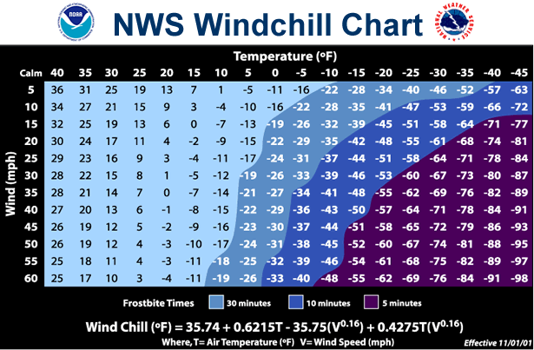  http://www.nws.noaa.gov/om/windchill/ |  | NWS – NOAA  National Weather  http://www.weather.gov/  River forecasts  http://water.weather.gov/ahps/  Storm Prediction Center  http://www.spc.noaa.gov/

