Revision Date: | 2015MAR | State of Illinois Emergency Management Agency | Hazard ID: | TORNADO
Revised By: |  |  | Use By:

SHORT-TERM RESPONSE OBJECTIVES |  | RESOURCE GUIDELINE FOR RESPONSE
- Conduct Search and Rescue  - Establish Immediate EMS/Medical Surge Capacity  - Provide Force Security & Protection  - Restore Communications  - Restore Power  - Restore WWTF and Potable Water Supplies/Systems  - Provide Public Information Messaging  - Establish Evacuation Systems  - Establish Shelters  - Provide Potable Water/Ice/Food  - Conduct Debris Removal  - Implement Debris Management  SECONDARY CONSIDERATIONS  - Environmental impact  - Long-term monitoring and clean-up  - Loss of economy and infrastructure  - Foodborne/waterborne illnesses  - Medical capacity and capability  - Monitoring, Sampling, and Mitigation  - Personnel Protective Equipment  - Psychological implications  - Secondary hazardous materials releases  - Secure access and area security  - Vendor and insurance fraud |  | RESOURCE TYPE | QNTY | PURPOSE
 |  | Telecom Repair Technicians  Telecom Repair Technicians  ICC Regional Representative  Sworn Officer – L/E  Generators ( 3-100kW, 3-30Kw) IESMA  Generator Support Trailer – IESMA  ITEC Team and Trailer  Offender Crews (1 L/E, 8 inmate/per)  End Loader  Chipper  Trucks w/ Plows  Back Hoe/Digger  Skid Steer  Chainsaws  Message Boards  Arrow Boards  Sweeper  Burn curtain  HWY Labor (Personnel)  Day Labor, General (Personnel)  FW Raytheon KA 350  Mobile Command  Communications Vehicle  Satellite Vehicle  Regional Command Trailers  Logistics Trailer  Cars, Passenger  Personnel – UAC – FWD AO  Personnel – UAC – FWD AO  EMAT – IESMA  Technical Rescue Team (MABAS) |  | Support IT/Telecom repairs – Govt. Facilities  Support IT/Telecom repairs – Remote CMD  Liaison w/ Private Sector – Transportation  Force Security and Protection / T/A  Power Restoration  Power Restoration  Communications Restoration  Debris Removal and Management  Debris Removal and Management  Debris Removal and Management  Debris Removal and Management  Debris Removal and Management  Debris Removal and Management  Debris Removal and Management  Debris Removal and Management  Debris Removal and Management  Debris Removal and Management  Debris Removal and Management  Debris Removal and Management  Debris Removal and Management/ Res Mgmt  Aerial Monitoring  UAC, RSOI, Logs Base, (C3)  Interoperable Communications / C3  Interoperable Communications / C3  FWD Command, Communications, D/A  Resource Management / Logistics / FWD AO  Transport / Damage Assessment / Mobility  Liaison / Staffing UAC  Recovery Specialists / DA  Emergency Management  Search and Rescue

 | SAFETY CONSIDERATIONS AND WARNINGS
- Staff will maintain a safe working environment throughout operations.
- Due to the extended working period, staff will be cognizant of stress, fatigue, and the need for adequate rest periods.
- All staff should be cognizant of potential lift, trip, fall, pinch, electrical, puncture, chemical and environmental hazards associated with operations.
- Any and all situations warranting law enforcement intervention will be immediately directed to the appropriate authorities. At no time will staff intercede in law enforcement activities.
- Injuries or medical concerns/conditions will be reported to the medical staff on-site immediately and/or 911 as appropriate.
DEBRIS ESTIMATION – Mixed & Vegetative Only |  |  | DEBRIS ESTIMATION - Homes | DEBRIS - RULES OF THUMB
Ground Measurements  One acre of debris 10 feet high converts to 16,133 CY  43,560 SF x 10 FT = 16,133 CY  27  Conversion Factors for tons and cubic yards of debris  Construction and demolition debris: 1 ton = 2 CY  Mixed debris: 1 ton = 4 CY  Vegetative debris:  Hardwoods: 1 ton = 4 CY  Softwoods: 1 ton = 6 CY  - 15 trees 8 inches in diameter = 40 cy (average)  - Root system (8’-10’ diameter) = one flatbed trailer  VCM for Single Family Homes  Typical House (Square Feet) Vegetative Cover Multiplier  None Light (1.1) Medium (1.3) Heavy (1.5)  1000 SF 200 CY 220 CY 260 CY 300 CY  1200 SF 240 CY 264 CY 312 CY 360 CY  1400 SF 280 CY 308 CY 364 CY 420 CY  1600 SF 320 CY 352 CY 416 CY 480 CY  1800 SF 360 CY 396 CY 468 CY 540 CY  2000 SF 400 CY 440 CY 520 CY 600 CY  2200 SF 440 CY 484 CY 572 CY 660 CY  2400 SF 480 CY 528 CY 624 CY 720 CY  2600 SF 520 CY 572 CY 676 CY 780 CY  - For multiple-story residences, the debris generated by the demolished residence should be calculated using the total number of stories. |  |  | Mobile Home Formulas  Typical single-wide mobile home: 290 CY  Typical double-wide mobile home: 415 CY  Personal Property on Public Rights-of-Way  Slab on grade home: 25–30 CY  Home with a basement: 45–50 CY  General Building Formula  Length x Width x Height x 0.33 = CY  27  Single Family Residence Formula  Length x Width x S x 0.20 x VCM = CY  - Length and Width must be in feet  - S = number of stories in the building  - 0.20 = a constant based on the study data  - VCM = a vegetative cover multiplier | - To convert cubic yards of Construction & Demolition (C&D) debris to tons, divide by 2.  Cubic Yards = ________T  2  - To convert tons of C&D debris to cubic yards, multiply by 2.  - To convert cubic yards of woody debris to tons, divide by 4.  Cubic Yards = ________T  4  - To convert tons of woody debris to cubic yards, multiply by 4.  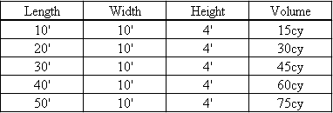
 |  |  | ENHANCED FUJITA SCALE |  | LINKS
 |  |  | 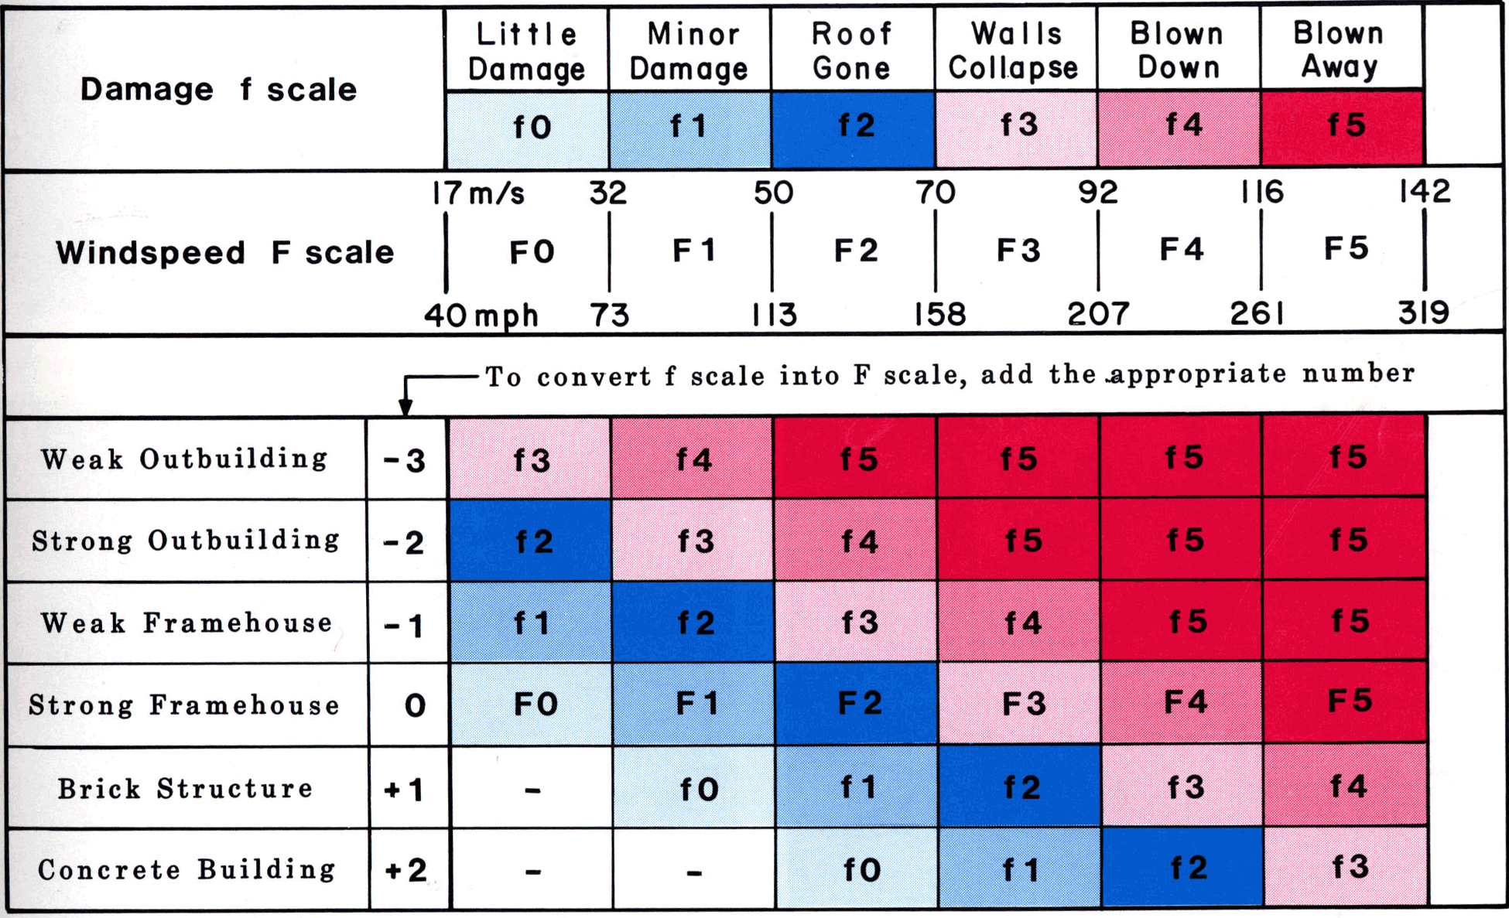  http://www.spc.noaa.gov/efscale/ |  | NWS – NOAA  National Weather  http://www.weather.gov/  River forecasts  http://water.weather.gov/ahps/  Storm Prediction Center  http://www.spc.noaa.gov/

